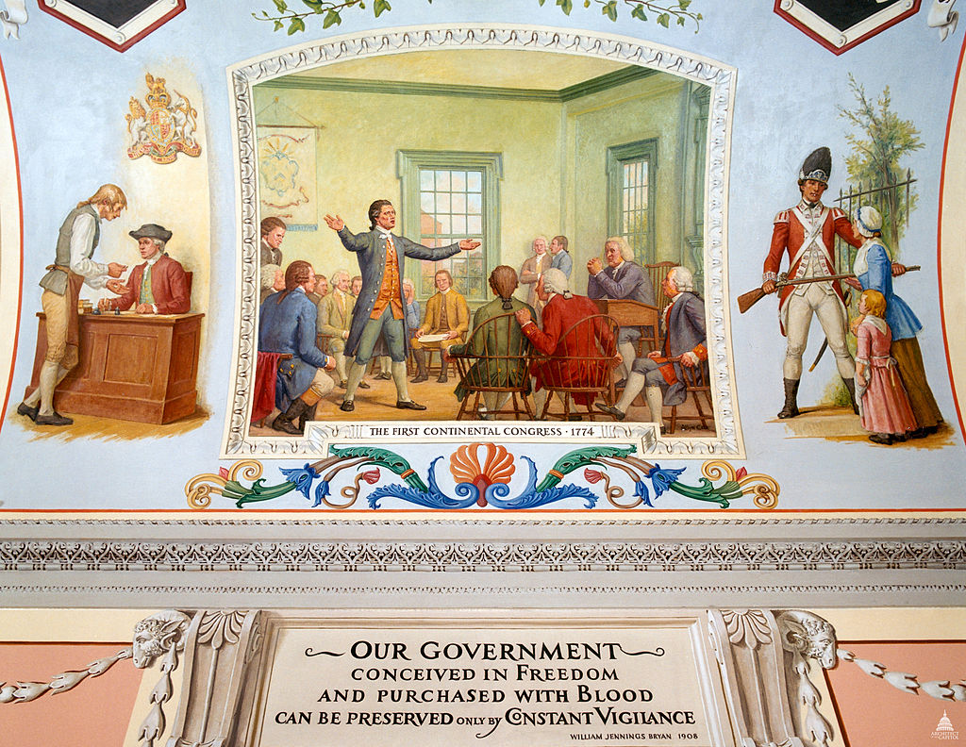

American Rights and Grievances
The Grand Committee issued its report of American rights and a list of grievances in late September. The report declared that the colonists had “never ceded to any sovereign power a right to dispose of their rights to life, liberty and property without their consent”. It also denounced several acts that included regulating trade for the purpose of raising revenue such as the Sugar Act and Tea Act.
The following are the resolves sent to the King, it was dated October 14, 1774:
Whereas, since the close of the last war, the British Parliament, claiming a power of right to bind the people of America, by statute in all cases whatsoever, hath in some acts expressly imposed taxes on them, and in others, under various pretenses, but in fact for the purpose of raising a revenue, hath imposed rates and duties payable in these colonies, established a board of commissioners, with unconstitutional powers, and extended the jurisdiction of courts of admiralty, not only for collecting the said duties, but for the trial of causes merely arising within the body of a county.
And whereas, in consequence of other statutes, judges, who before held only estates at will in their offices, have been made dependent upon the crown alone for their salaries, and standing armies kept in times of peace:
And it has lately been resolved in Parliament, that by force of a statute, made in the thirty-fifth year of the reign of King Henry the Eighth, colonists may be transported to England, and tried there upon accusations for treasons, and misprisions, or concealments of treasons committed in the colonies; and by a late statute, such trials have been directed in cases therein mentioned.
And whereas, in the last session of Parliament, three statutes were made; one, entitled “An act to discontinue, in such manner and for such time as are therein mentioned, the landing and discharging, lading, or shipping of goods, wares and merchandise, at the town, and within the harbor of Boston, in the province of Massachusetts Bay, in North America”; another, entitled “An act for the better regulating the government of the province of the Massachusetts Bay in New England”; and another, entitled “An act for the impartial administration of justice, in the cases of persons questioned for any act done by them in the execution of the law, or for the suppression of riots and tumults, in the province of the Massachusetts Bay, in New England.” And another statute was then made, “for making more effectual provision for the government of the province of Quebec, etc.” All which statutes are impolitic, unjust, and cruel, as well as unconstitutional, and most dangerous and destructive of American rights.
And whereas, assemblies have been frequently dissolved, contrary to the rights of the people, when they attempted to deliberate on grievances; and their dutiful, humble, loyal, and reasonable petitions to the crown for redress have been repeatedly treated with contempt by His Majesty’s ministers of state:
The good people of the several colonies of New Hampshire, Massachusetts Bay, Rhode Island and Providence Plantations, Connecticut, New York, New Jersey, Pennsylvania, Newcastle, Kent and Sussex on Delaware, Maryland, Virginia, North Carolina, and South Carolina, justly alarmed at these arbitrary proceedings of Parliament and administration, have severally elected, constituted, and appointed deputies to meet and sit in General Congress, in the city of Philadelphia, in order to obtain such establishment, as that their religion, laws, and liberties may not be subverted:
Whereupon the deputies so appointed being now assembled, in a full and free representation of these colonies, taking into their most serious consideration, the best means of attaining the ends aforesaid, do, in the first place, as Englishmen, their ancestors in like cases have usually done, for asserting and vindicating their rights and liberties, declare,
That the inhabitants of the English Colonies in North America, by the immutable laws of nature, the principles of the English constitution, and the several charters or compacts, have the following rights:
Resolved, N.C.D. ² 1. That they are entitled to life, liberty, and property, and they have never ceded to any sovereign power whatever, a right to dispose of either without their consent.
Resolved, N.C.D. 2. That our ancestors, who first settled these colonies, were, at the time of their emigration from the mother-country, entitled to all the rights, liberties, and immunities of free and natural-born subjects, within the realm of England.
Resolved, N.C.D. 3. That by such emigration they by no means forfeited, surrendered, or lost any of those rights, but that they were, and their descendants now are, entitled to the exercise and enjoyment of all such of them, as their local and other circumstances enable them to exercise and enjoy.
Resolved, 4. That the foundation of English liberty, and of all free government, is a right in the people to participate in their legislative council: and as the English colonists are not represented, and from their local and other circumstances, cannot properly be represented in the British Parliament, they are entitled to a free and exclusive power of legislation in their several provincial legislatures, where their right of representation can alone be preserved, in all cases of taxation and internal polity, subject only to the negative of their sovereign, in such manner as has been heretofore used and accustomed. But, from the necessity of the case, and a regard to the mutual interest of both countries, we cheerfully consent to the operation of such acts of the British Parliament, as are bonafide, restrained to the regulation of our external commerce, for the purpose of securing the commercial advantages of the whole empire to the mother-country, and the commercial benefits of its respective members; excluding every idea of taxation, internal or external, for raising a revenue on the subjects in America, without their consent.
Resolved, N.C.D. 5. That the respective colonies are entitled to the common law of England, and more especially to the great and inestimable privilege of being tried by their peers of the vicinage, according to the course of that law.
Resolved, 6. That they are entitled to the benefit of such of the English statutes as existed at the time of their colonization; and which they have, by experience, respectively found to be applicable to their several local and other circumstances.
Resolved, N.C.D. 7. That these His Majesty’s colonies, are likewise entitled to all the immunities and privileges granted and confirmed to them by royal charters, or secured by their several codes of provincial laws.
Resolved, N.C.D. 8. That they have a right peaceably to assemble, consider of their grievances, and petition the king; and that all prosecutions, prohibitory proclamations, and commitments for the same are illegal.
Resolved, N.C.D. 9. That the keeping a standing army in these colonies, in times of peace, without the consent of the legislature of that colony, in which such army is kept, is against law.
Resolved, N.C.D. 10. It is indispensably necessary to good government, and rendered essential by the English constitution, that the constituent branches of the legislature be independent of each other; that, therefore, the exercise of the legislative power in several colonies, by a council appointed, during pleasure, by the crown, is unconstitutional, dangerous, and destructive to the freedom of American legislation.
All and each of which the aforesaid deputies, in behalf of themselves and their constituents, do claim, demand, and insist on, as their indubitable rights and liberties; which cannot be legally taken from them, altered or abridged by any power whatever, without their own consent, by their representatives in their several provincial legislatures.
In the course of our inquiry, we find many infringements and violations of the foregoing rights, which, from an ardent desire, that harmony and mutual intercourse of affection and interest may be restored, we pass over for the present, and proceed to state such acts and measures as have been adopted since the last war, which demonstrate a system formed to enslave America.
Resolved, N.C.D. That the following acts of Parliament are infringements and violations of the rights of the colonists; and that the repeal of them is essentially necessary in order to restore harmony between Great Britain and the American colonies, viz.:
The several acts of 4 Geo. 3, ch. 15, and ch. 34. — 5 Geo. 3, ch. 25. — 6 Geo. 3, ch. 52. — 7 Geo. 3, ch. 41, and ch. 46. — 8 Geo. 3, ch. 22, which impose duties for the purpose of raising a revenue in America, extend the powers of the admiralty courts beyond their ancient limits, deprive the American subject of trial by jury, authorize the judges’ certificate to indemnify the prosecutor from damages, that he might otherwise be liable to, requiring oppressive security from a claimant of ships and goods seized, before he shall be allowed to defend his property, and are subversive of American rights.
Also the 12 Geo. 3, ch. 24, entitled “An act for the better securing His Majesty’s dockyards, magazines, ships, ammunition, and stores,” which declares a new offense in America, and deprives the American subject of a constitutional trial by a jury of the vicinage, by authorizing the trial of any person, charged with the committing any offense described in the said act, out of the realm, to be indicted and tried for the same in any shire or county within the realm.
Also the three acts passed in the last session of Parliament, for stopping the port and blocking up the harbor of Boston, for altering the charter and government of the Massachusetts Bay, and that which is entitled “An act for the better administration of justice,” etc.
Also the act passed in the same session for establishing the Roman Catholic religion in the Province of Quebec, abolishing the equitable system of English laws, and erecting a tyranny there, to the great danger, from so total a dissimilarity of religion, law, and government of the neighboring British colonies, by the assistance of whose blood and treasure the said country was conquered from France.
Also the act passed in the same session for the better providing suitable quarters for officers and soldiers in His Majesty’s service in North America.
Also, that the keeping a standing army in several of these colonies, in time of peace, without the consent of the legislature of that colony in which such army is kept, is against law.
To these grievous acts and measures, Americans cannot submit, but in hopes that their fellow-subjects in Great Britain will, on a revision of them, restore us to that state in which both countries found happiness and prosperity, we have for the present only resolved to pursue the following peaceable measures:
Resolved, unanimously, That from and after the first day of December next, there be no importation into British America, from Great Britain or Ireland of any goods, wares or merchandise whatsoever, or from any other place of any such goods, wares or merchandise. ³
1. To enter into a nonimportation, nonconsumption, and nonexportation agreement or association.
2. To prepare an address to the people of Great Britain, and a memorial to the inhabitants of British America, and
3. To prepare a loyal address to His Majesty; agreeable to resolutions already entered into.
~~~~~~~~~~~~~~~~~~~~~~~~~~~~~~~~~~~~~~~~~~~~~~~~~~~~~~~~~~~~~~~~~~~~~~~~~~~~~~~~~~~~
1. Journals of the Continental Congress, 1774-1789 (Washington, 1904), I, 63-73.
2. i.e., nemine contradicente, meaning without a dissenting vote or unanimously. Commenting on these proceedings before a committee of the British House of Commons, in June, 1779, Galloway stated that, although the resolutions were recorded as having been passed unanimously, this meant not that they were approved by every member present but by a majority of each delegation (The Examination of Joseph Galloway ... before the House of Commons ... , 2d ed.; London, 1780, p. 61).
3. This paragraph was struck out.
~~~~~~~~~~~~~~~~~~~~~~~~~~~~~~~~~~~~~~~~~~~~~~~~~~~~~~~~~~~~~~~~~~~~~~~~~~~~~~~~~~~~
Definitions from Mr. C:

Indispensably: can’t live without it

Indubitable (ĭn-do͞oˈbĭ-tə-bəl): too apparent to be doubted; unquestionable (Think Looney Tunes with Daffy Duck. Replace this word with “obvious” or “obviously” and the sentence typically makes sense.)

Infringements: a breach or infraction / breaking of a law, right, or obligation; violation; transgression.

Vicinage (‘vis-nij): a neighboring or surrounding district, the vicinity

viz. : namely, that is to say, as follows, specifically, as an illustration (Replace the Latin abbreviation “viz” with “as an example” and the sentence typically makes sense.)
- From the Latin videlicet (“that is to say, namely”)
- Short for videre licet (“it is permitted to see ”)

